Design and Development of an Electric Toy Car Powered by a Fuel Cell Stack
Student Name: ZHAO Xuecen
Student ID: 22014303d
Department: Mechanical Engineering
Team members: YIP Tsz Yeung Oscar BME, SEN Bijoy EEE
Supervisor: Prof. AN Liang
Second Supervisor: Prof. Wu Maochun
Teaching assistant: Mr. Xin LONG
Date: September 2025

Abstract
This individual project proposal focuses on my primary role in the inter-departmental Final Year Project: the design and fabrication of components for a passive direct liquid fuel cell stack powered by vanadium-based electrically rechargeable liquid fuel (e-fuel).
As a Mechanical Engineering student, I will lead the development of the fuel cell's core elements, including the anode, cathode, membrane, current collectors, and overall stack assembly, to enable efficient power generation for an electric toy car prototype. This addresses limitations of traditional batteries and fuel cells, such as long charging times and high costs, by leveraging e-fuel's rechargeability and catalyst-free operation. My contributions will integrate with team efforts on performance evaluation and toy car prototyping. The methodology emphasizes mechanical design using SolidWorks, AI training using Python, and toy car fabrication using sheet metal and 3D print.
1. Introduction
In this inter-departmental FYP, the overall project aims to prototype an electric toy car powered by a passive vanadium e-fuel cell stack, demonstrating sustainable energy solutions. My individual role, as a Mechanical Engineering student, centers on the fuel cell design and components fabrication, the foundational aspect enabling the system's functionality. This involves creating a passive stack that operates without pumps or blowers, relying on diffusion and natural convection for fuel delivery.
Traditional lithium-ion batteries limit range and require hours to charge, while hydrogen fuel cells pose handling challenges. Vanadium e-fuel offers advantages like quick refueling (~5 minutes), no noble metal catalysts, and high reactivity, as highlighted in the project proposal. By focusing on design and fabrication, I will ensure the stack's mechanical integrity, electrochemical compatibility, and scalability, contributing to the project's innovation in portable power systems.
2. Literature Review
Fuel cells convert chemical energy directly into electricity through electrochemical reactions, offering high efficiency and low environmental impact compared to internal combustion engines. A comparative study of fuel cell technologies highlights that direct liquid fuel cells (DLFCs) provide ease of fuel handling and high energy density, surpassing gaseous hydrogen systems in portability. However, traditional DLFCs using methanol or ethanol require noble catalysts and yield limited performance.
Vanadium-based systems, particularly vanadium redox flow batteries (VRFBs), have emerged as promising due to their scalability and long cycle life. A comprehensive review of VRFBs emphasizes design considerations like electrode compression (optimal at 25%) and electrolyte flow rates (37.5-150 cm³/min), which enhance energy efficiency up to 85% while addressing limitations such as capacity fading through thermal treatments at 390-415°C. Operational conditions in VRFBs, including electrolyte flow and membrane type, significantly impact performance; for instance, anion exchange membranes yield higher efficiency than Nafion but with greater fading.
Recent advancements focus on electrically rechargeable liquid fuels (e-fuels) for DLFCs. A 2020 study demonstrated an e-fuel cell with a catalyst-free graphite-felt anode and air cathode, achieving a peak power density of 293 mW/cm² and 42.3% energy efficiency at room temperature. This system uses vanadium ions in sulfuric acid, enabling rechargeability and superior reactivity over alcohol. Passive designs further simplify the system. A 2021 passive e-fuel cell reported 116.2 mW/cm² with over 350 hours of stability.
Key components include thermally treated graphite anodes, cathodes, Nafion membranes, and vanadium electrolytes (1.0-1.6M V in 2-4M H₂SO₄). Fabrication involves MEA assembly, and current collectors with optimized open ratios. These insights guide my role in addressing fabrication challenges like electrolyte stability and mechanical durability.
3. Objectives
As a team, the objective of our project is:
Design, fabricate, and integrate fuel cell components for a passive DLFC stack using vanadium e-fuel. The stack is expected to be capable of attaining an OCV of 1.4 V, a maximum current of 2.5 A, and a peak power of 2.0 W at room temperature, running time for a minimum of 10 minutes under normal operating conditions.
Evaluate and optimize fuel cell performance through experiments (polarization curves, impedance spectroscopy) and numerical modeling (for flow and efficiency).
Prototype an electric toy car integrating the fuel cell stack with powertrain, electronic controls, and AI navigation features for demonstration.
My focused objectives, and my ME expertise, are:
- Design the passive fuel cell stack, including anode, cathode, membrane, current collectors, and flow fields, using CAD tools for mechanical optimization communicate closely with our BME teammate to calculate suitable size and reaction area of the cell.
- Fabricate fuel cell components through processes like CAD design, CNC, and assembly, ensuring use of suitable materials.
- Integrate fabricated components into a stack prototype, supporting team efforts in evaluation and toy car assembly.
- Train the AI model with our EEE teammate.
4. Methodology
4.1 Fuel Cell Design 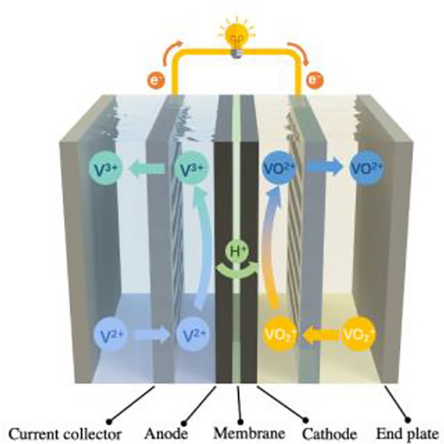
Use SolidWorks/AutoCAD to model a passive vanadium e-fuel cell stack
Incorporate serpentine or perforated flow fields in current collectors (graphite, open ratio 50-70% for optimal diffusion).
Design the e-fuel tank from acrylic/PVC for safe storage (at least 20 mL capacity for each cell), with injection ports. Ensure passive operation via natural convection, utilize the vibration when driving to increase convection.
The other factor I need to take into consideration when designing the battery is the refilling process, the battery stack we will make will require relatively high voltage and power, so to make sure every refill only takes reasonable amount of time, we must take it into consideration when designing the stack.
*Power for the cell is directly tied to active area, as it determines the electrochemical reaction sites; voltage losses are minimized through electrode treatments, but area scaling requires careful design. Larger areas can indirectly reduce voltage due to increased ohmic losses (resistance to ion/electron flow) or mass transport limitations if flow distribution is uneven.
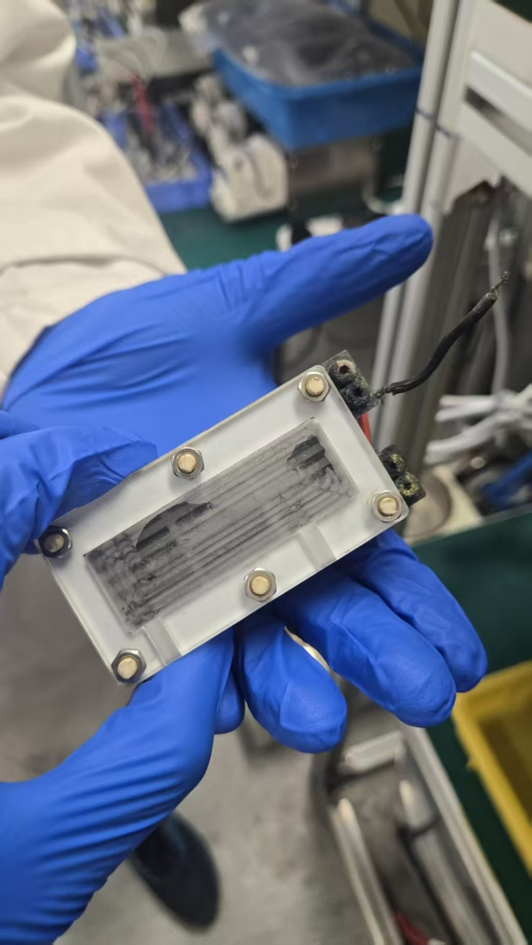
We are provided with a design done by previous FYP student for reference; there were a few rooms for improvement with this design that I notice:
- The refuelling is extremely difficult on this design as the opening are very small. Affecting its scalability as it will become very difficult to refuel it after we increase the stack.
- The tank for the design is small, since e-fuel already have poor power density, the battery will not be able to last very long.
- It is easy to mess up the refuelling as the fuel filler are all at one side of the battery.
- It is also difficult to remove used fuel on this design.
- The fuel filler does not have a cover, which means the fuel may spill and corrode our parts.
So, for our design I will make sure the battery has an easy refuel process, larger fuel tank combined with better utilization of car motion for better convection. Fuel filler covers to prevent leakage, with clear indication of cathode and anode.
4.2 Components Fabrication
Fuel cell (Fuel cell stack):
Component name | Method of fabrication, material, obtainment | Picture
Electrodes | Provided by department, graphite felt, we can modify the size and punch holes to increase surface area. | 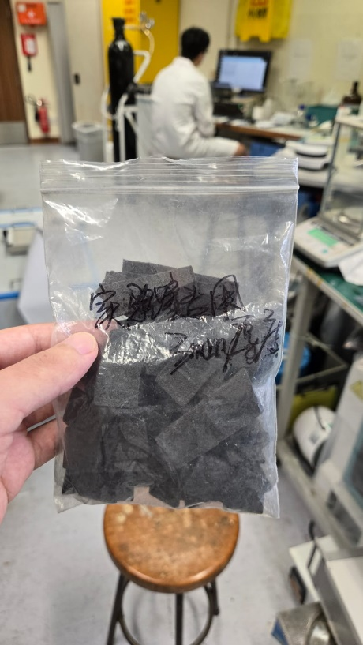
Membrane | Provided by department, Nafion 212 | 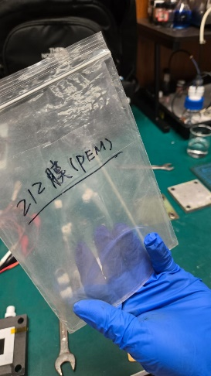
Current Collectors | Graphite plates with perforations/channels. We need to design the shape, size and reaction area, then custom made the component with a company. | 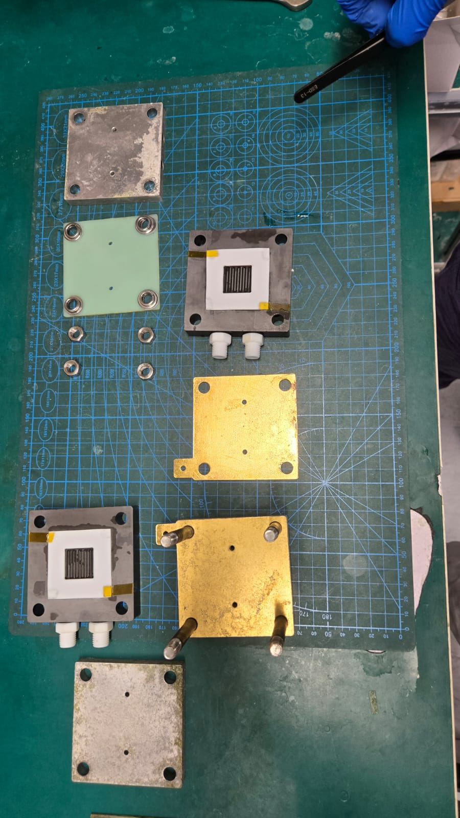
Gasket | PTFE plate, provided by department, can be modified to fit the current collector.
e-fuel tank | Design through solid work, fabricated through laser cut acrylic/3D print PVC. | 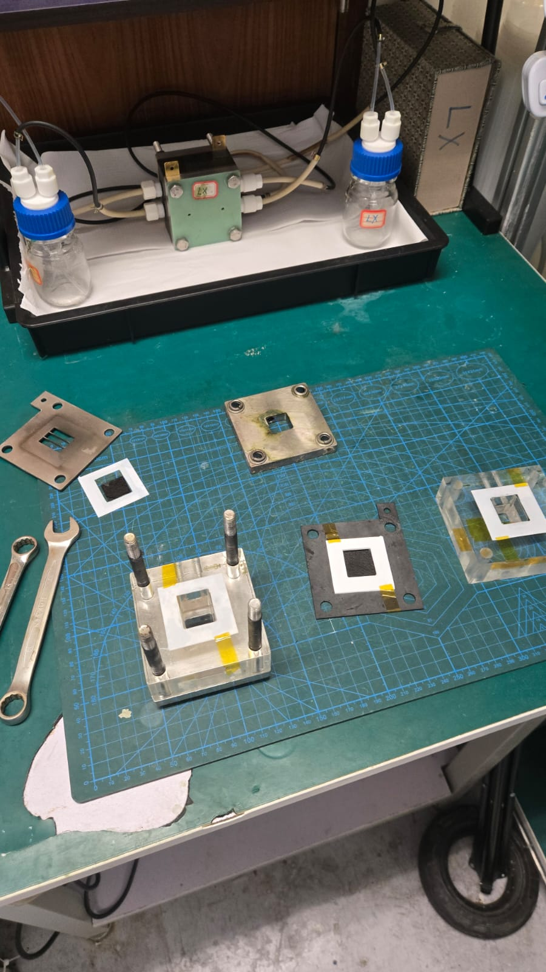
Assembly | Fabricate MEA by pressing anode, membrane, and cathode; embed in gaskets, using bolts for compression. Test for leaks.  I will make a stackable design so we can connect multiple batteries in series for higher current

Electrolyte(e-fuel) Preparation/ analysis:
Step | Description | Picture
1 | The concentration of Vanadium and sulfuric acid will be the main variable in this experiment.  Using 1 L of 1.0 M VOSO4 + 3.0 M H2SO4 for example:  Place a 1L large beaker on the scale and tare the weight. Weigh 246.416g of vanadium. Pour approximately 300-400 mL of DI water into the large beaker. Fill a 200 mL cylinder with 160 mL of 98% sulfuric acid. Slowly pour the sulfuric acid into the 1L beaker, while stirring continuously. | 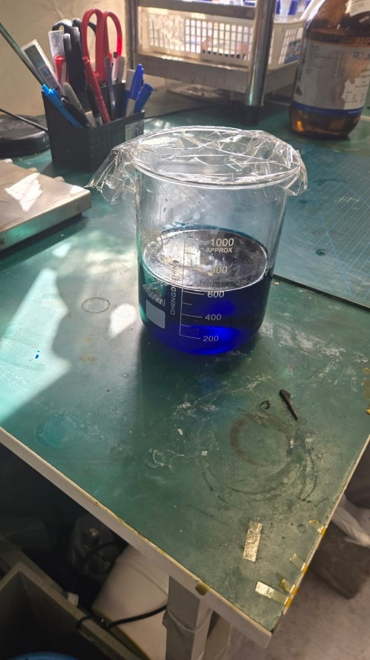
2 | V³⁺and V⁵⁺:  Place 2 portion of equal amount electrolyte into 2 beakers and connect it to the active pump charging unit, after charging, we will get V³⁺ at the Cathode and V⁵⁺ at the Anode. | 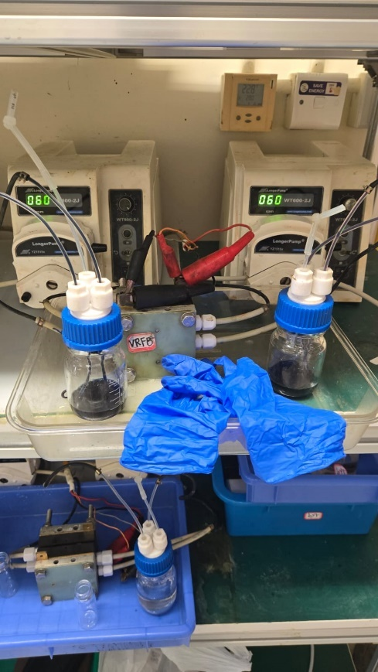
3 | V²⁺and V⁵⁺:  Remove the beaker at the Anode and replace with fresh electrolyte from step 1, and start the charging process, after charging we will have V²⁺ at the Cathode and V⁵⁺ at the Anode. | 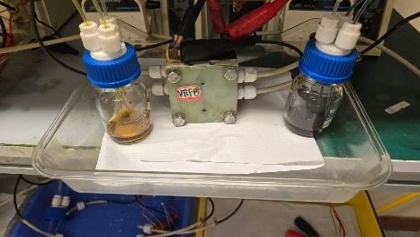
4 | Discharge the electrolyte and analyze the resulted IV graph and general performance of the fuel. | 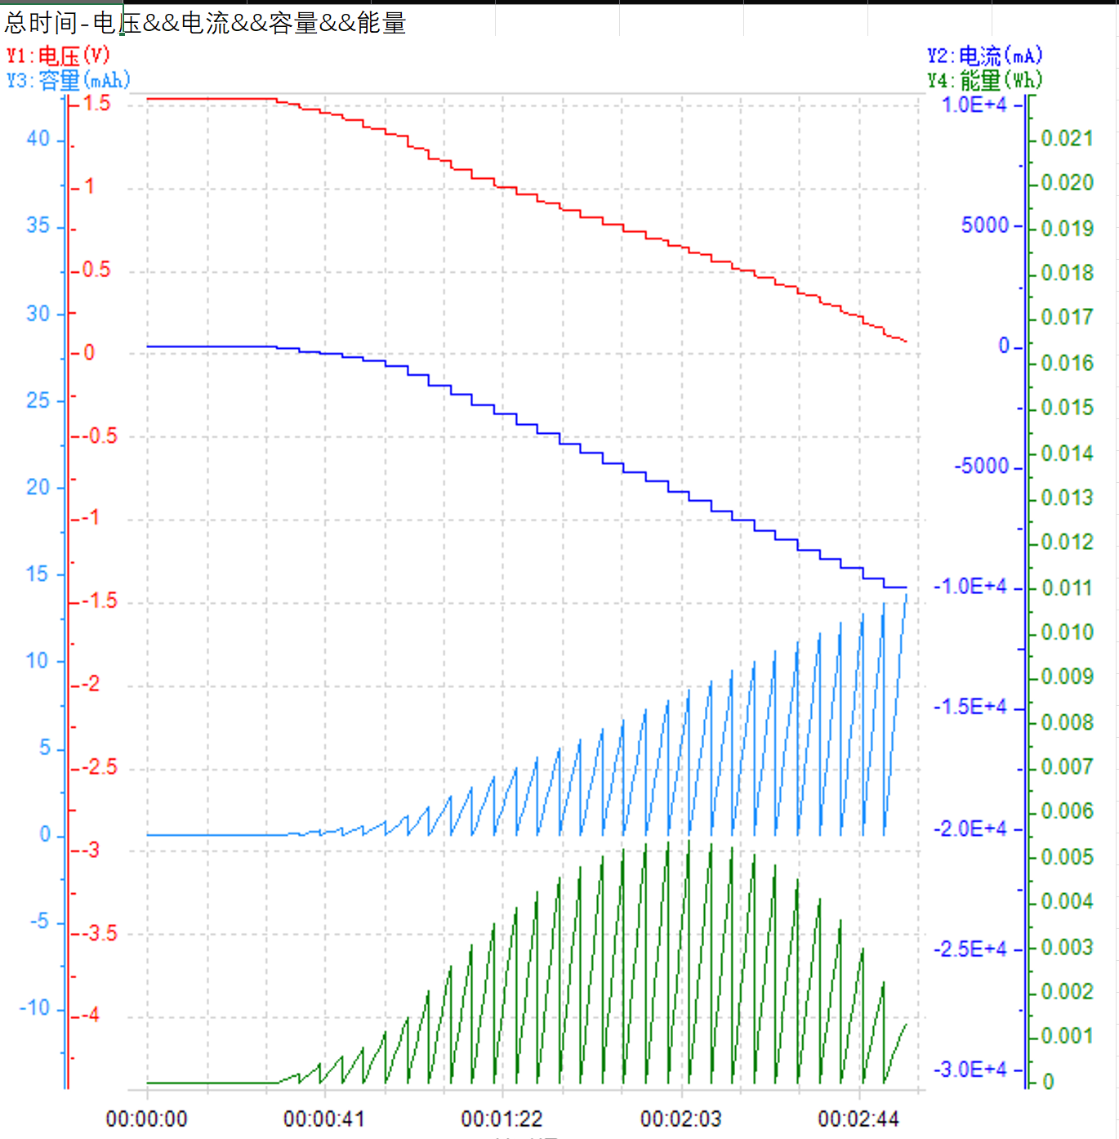

4.3 Toy Car Prototyping
Integrate cell stack with DC motor, wheels, and Jetson nano-based electronics for remote control and smart obstacles detection. The system will be supported with imbedded AI, ran locally that’s able to detect different items. Toy car parts design through SolidWorks and fabricated with 3D printing and sheet metal, wheel/tire DC motor purchased online.
Test system for operation and refueling duration.
Provide fabricated stack for team-led testing and toy car prototyping (motor/AI integration).
We will have a backup lithium battery in case the fuel cell cannot supply enough energy to the Ai system, and the e-fuel battery will power the mechanical part while the lithium battery powers the software.
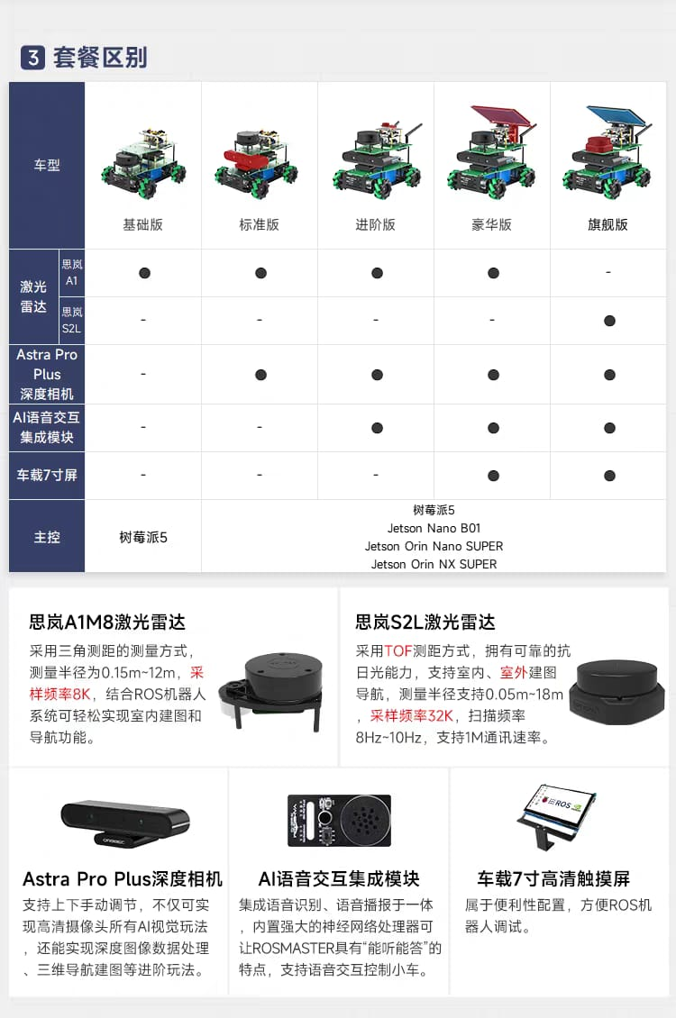
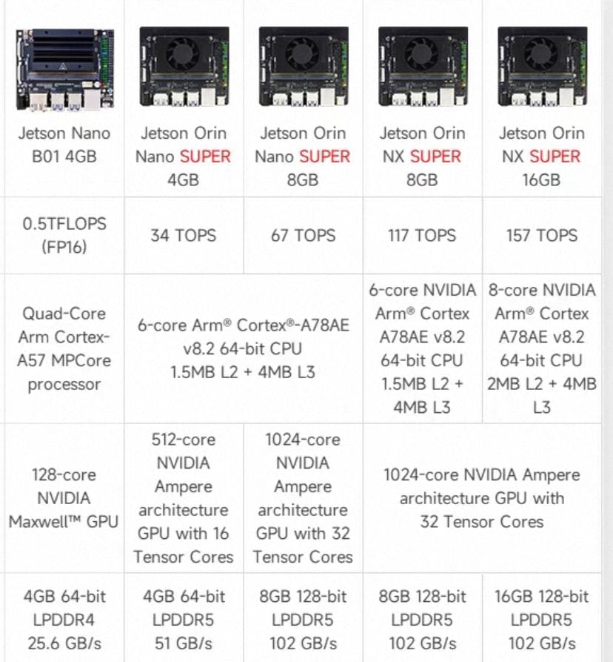

4.5 Ai training
Use a locally trained AI model running on Docker from a PC, received through the ROS on Jetson nano on the toy car. Using YOLO, we can train the AI to detect obstacles on the road and react accordingly. Combined with depth camera and radar to achieve tracking and obstacle detection.
4.5 Product demonstration
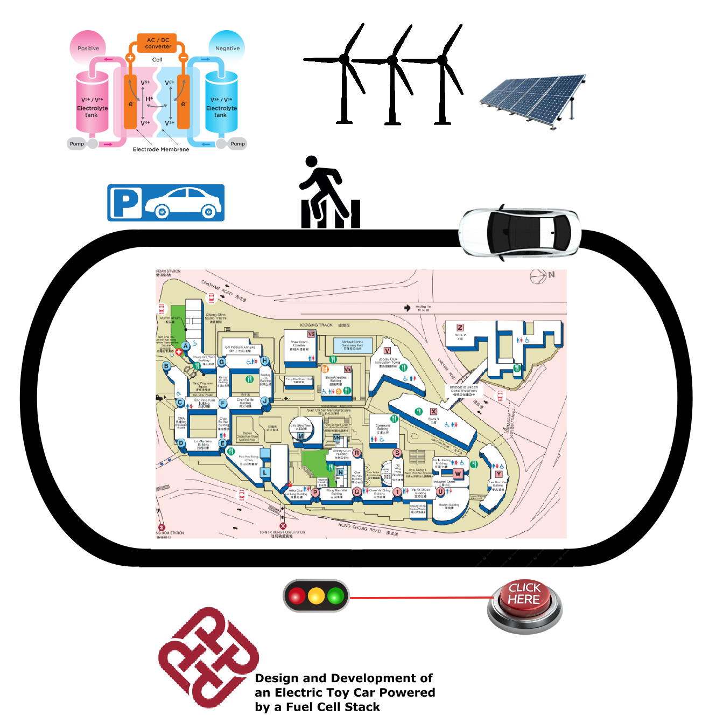
Simple automatic drive track that can demonstrate the car’s Ai features, as shown on the picture above, we will make a map with interactive traffic lights, parking and zebra crossings with passing pedestrians, the car will drive around a blueprint or 3D print of Polyu if there is sufficient time. We will also add the working principle of the e fuel and simple demonstration with color water to show the process of charging and discharging, also emphasizing the positive environmental impact of the fuel.
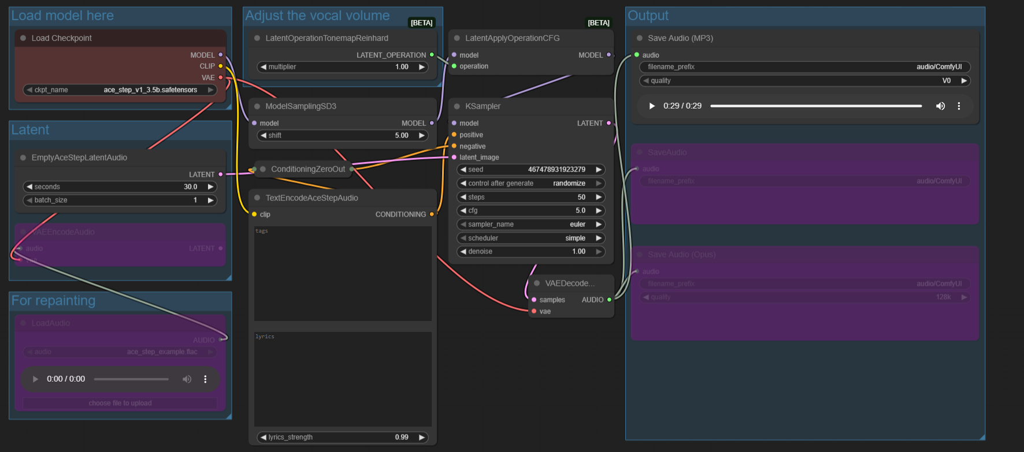
If time allow, we can even add voice control and run an open source LLM on Ollama to reply to people’s questions, like “Tell me more about the future of Vanadium batteries.” “Who designed this project.” “Please go back to the parking station.” etc using ComfyUi.
General idea for how to achieve this:

To achieve this, we will have a microphone at the stand, and the input will be processed through the PC and then let the toy car react accordingly.
5. Work Plan and Timeline
Semester 1 (Sep-Dec 2025): Literature review and experiment (Sep), experiment and design modeling (Oct), fuel cell components fabrication and initial assembly (Nov-Dec); mid-term report(Sep-Dec).
Winter Break (Dec 2025-Jan 2026): Initial testing and optimization, refine fabrication based on preliminary tests.
Semester 2 (Jan-May 2026): Stack assembly, toy car integration, full testing, final report, Demonstration stand.
Phase | Timeline | Tasks
Research & Design | Sep-Oct 2025 | Literature review, CAD modeling, experiment
Fabrication | Nov-Dec 2025 | Electrode treatment, MEA assembly, AI training
Assembly & Support | Jan-Apr 2026 | Stack build, team collaboration, demonstration stand
Reporting | May 2026 | Final deliverables

6. Resources and Budget
Facilities: ME labs for cell fabrication/testing. Inter-departmental access (EEE lab for circuits, IC for assembly and 3D print).
Total funding of HKD 60,000 from department
Software: SolidWorks, MATLAB, Adobe Illustrate, VS Code (university licensed).
Ai system(Jetson nano)(~HKD 4000).
Car body (~HKD 5000).
Battery manufacturing(HKD 10000).
Demonstration stand (HKD 2000-5000).
7. References
Shi et al. (2020). Energizing Fuel Cells with an Electrically Rechargeable Liquid Fuel. Cell Reports Physical Science.
Shi et al. (2021). A Passive Fuel Cell Fed with an Electrically Rechargeable Liquid Fuel. ACS Applied Materials & Interfaces.
Monteiro et al. (2018). Insights into all-vanadium redox flow battery: A case study on components and operational conditions. Electrochemical Acta.
Shi et al. (2025). Operation of a Passive Fuel Cell Under Sub-Zero Environment Conditions. Automotive Innovation.
Mekhilef et al. (2012). Comparative study of different fuel cell technologies. Renewable and Sustainable Energy Reviews.
Lourenssen et al. (2019). Vanadium redox flow batteries: A comprehensive review. Journal of Energy Storage.
Larminie and Dicks (2003). Fuel Cell Systems Explained (2nd Edition). John Wiley & Sons.

